7/28/2026

FRONT COVER
Schedule
WADA Workshop – 2010

X

X

X

X

X

X

X

X

X

X

X

“Athletic Administration
Whatever it takes!”
A Message from the President:  On behalf of the WADA Executive Board of Directors, I would like  to welcome you to the 44th annual WADA Workshop and the  Chula Vista Resort & Conference Center!  Professional Development---We are very proud of the professional development opportunities provided at this conference and the opportunity to network with peers and mentors. We believe the information and training you gain is relevant to your role in athletic administration and will be immediately applicable to your responsibilities. This year we are proud to welcome three featured keynote speakers, Bruce Brown from Proactive Coaching LLC, Barry Alvarez, University of Wisconsin-Madison Athletic Director, and Dr. Stuart Robertshaw, nationally well-known humorist.  Professional Development is the focus of this workshop with 12 NIAAA Leadership Training Institute courses, all of which can be taken for credit through Edgewood College. Additionally, there are 18 diverse mini-sessions planned by Pam Huston, CAA, D.C. Everest, as part of the responsibilities of President Elect. There is also a Packer Party on Sunday evening, a Monday Night Football party with a slider grill and ice cream sundae bar and a great Fellowship of Christian Athletes Breakfast on Tuesday morning with a featured speaker. We ask that you make sure to visit the eighty-plus vendors at our workshop this year. It is because of them and their generous support that we can offer an outstanding professional conference every year.  Distinguished Service Recognition---We look forward to the opportunity to recognize individuals who are great contributors to athletic programs across the state as we honor recipients of our Distinguished Service Award at the banquet on Sunday night. Their countless hours of service insure quality programs and opportunities for student athletes state-wide. We also look forward to recognizing our own colleagues who have represented their schools and communities with such professionalism at our Awards Luncheon on Monday.  Appreciation---We gratefully acknowledge our keynote presenters, mini-session presenters & presiders, LTI faculty, our retired athletic directors who come back each and every year, and all of the other athletic administrators that have worked so hard to make this Workshop a success. A special thank you goes to our partners: Dave Anderson, WIAA Executive Director; Deb Hauser, WIAA Liaison to the WADA Executive Board; and the WIAA staff.  I would like to extend the Board’s thanks to Rebecca Walters, Amber Kaminski and their great staff here at the Chula Vista Resort & Conference Center for their assistance with the planning and implementation of this year’s event. We hope your family is here to enjoy the many wonderful amenities of this resort and we hope you agree that this location is a family-oriented site that meets the professional needs of our organization and the personal needs of our athletic administrators and their families. | Linzi Otjen Gronning CMAA, WADA President  Holmen  . WADA .  Wisconsin Athletic Directors Association  WADA is a forward-thinking organization serving and supporting its members  in the profession of athletic administration.  WADA will be a vibrant, highly educated, motivated, member driven organization providing quality leadership.
  MISSION
  VISION
I would ask for your assistance in extending appreciation to the WADA Executive Board for their hard work throughout the year on behalf of all members. The WADA E-Newsletter took off this year and I would like to recognize Luke Francois, CMAA, Middleton and WADA Vice President, who took over as editor. Additionally, I would like to acknowledge the efforts of the Board in undertaking the special project of the WADA Coach Handbook. Their time, dedication and commitment to “all things WADA” has been remarkable and they have lived this year’s theme, Athletic Administration-Whatever it takes! I would also like to acknowledge the support of the Holmen School Board, administration, coaches, community and my family as I undertook responsibilities as a WADA Board member and officer.
WADA Workshop Experience---Your Board has worked hard to make this a great professional growth opportunity and one where you can connect with others across the state. We hope you take time to make new friends and have some FUN!! Again, welcome to the WADA Workshop and Chula Vista! I hope you find this workshop to be of great professional value and an opportunity to make lasting friendships with athletic administrators across the state. It has been my privilege to serve this year as your President! Enjoy the Workshop and have a safe trip home!

WADA EXECUTIVE BOARD
* President Linzi Gronning, CMAA Holmen
* President Elect Pam Huston D.C. Everest
* Vice-President Luke Francois, CMAA Middleton
* Past President Greg Smith, CMAA West De Pere
Treasurer Joe Beran, CAA La Crosse Central
District I Ray Kosey Superior
District II Stephanie Hauser, CAA Stevens Point Area Senior High
District III Bryan Yager, CAA Reedsburg Area
District IV Kathy Bates, CMAA Xavier
District V Brian Smith Waunakee
District VI Signe Schecher Mayville
District VII Corey Golla Brookfield East
Information Director Mike Bates Appleton
Retired AD’s Liaison Jim Scandin Madison, Retired
NIAAA Liaison Vickie Dahl, CAA Mineral Point
WIAA Liaison Deb Hauser WIAA, Associate Director
Middle Level Liaison Eric Check La Crosse Lincoln MS
* denotes officers

. WADA .
Wisconsin Athletic Directors Association
serving athletic directors throughout Wisconsin

www.wadawi.org |  |  |  | www.niaaa.org

Workshop Schedule – 2010

SATURDAY, NOVEMBER 6, 2010
As a courtesy to our presenters, please turn off cell phones during all presentations.
This includes mini-sessions, LTI classes, keynote addresses, etc.

3:30 WADA OFFICERS MEETING Executive Board Room
Pre-Workshop Meeting with Hotel Staff
4:00 WADA EXECUTIVE BOARD MEETING Executive Board Room

6:30 –7:30 PAST PRESIDENTS’ SOCIAL North Tower - Room 3001
Hosts: Dave and Jane Gunderson, Retired
Jack and Joan Cepek, Retired
7:30 PAST PRESIDENTS’ DINNER Laguna
Host: Greg Smith, CMAA, WADA Past President, West De Pere
Invocation: Luke Francois, CMAA, Middleton

MARK YOUR CALENDAR:  WADA Workshop  Chula Vista Resort & Conference Center  Saturday thru Tuesday  Nov. 6, 7, 8, 2011  Nov. 4, 5, 6, 2012  Nov. 3, 4, 5, 2013 |  | 

SUNDAY, NOVEMBER 7, 2010

As a courtesy to our presenters, please turn off cell phones during all presentations.
This includes mini-sessions, LTC classes, keynote addresses, etc.
9:00 a.m. WADA EXECUTIVE BOARD MEETING Executive Board Room

9:00 – 5:00 WORKSHOP REGISTRATION Grand Ballroom Lobby
Joe Beran, CAA, WADA Treasurer, La Crosse Central
Jim Scandin, WADA Retired AD’s Liaison
WADA Retired Athletic Directors

9:30 – 1:30 NIAAA LEADERSHIP TRAINING INSTITUTE – Please turn off cell phones
* Pre Registration and Advance Fee Required.
Meal Provided.

LTC – 502 Conference Center A
Athletic Administration: Principles, Strategies & Methods
Facilitators: Don Dalton, CAA, Retired Stephanie Hauser, CAA, Stevens Point Area Senior High
LTC – 611 Conference Center B
Athletic Administration: Concepts and Strategies for Interscholastic Marketing, Promotions and Supplemental Fund-Raising
Facilitators: John Frizzell, CMAA, Chippewa Falls, & Luke Francois, CMAA, Middleton

LTC – 617 Conference Center C
Athletic Administration: Administration of Interscholastic Sports Medicine Programs
Facilitators: Scott Lindgren, CMAA, Kenosha, & Rick Johns, CMAA, University School

LTC – 705 Conference Center D
Athletic Administration: Coach Centered Educational Athletics-A Character Based Coach to Coach Mentoring Program
Facilitators: Brian Yager, CAA, Reedsburg Area, & Don Tolkacz, CAA, Retired AD

LTC – 724 Conference Center E
Athletic Administration: Stress Management Methods, Techniques and Systems
Facilitator: Tina Woolard, CAA, Grayslake North High School, IL

LTC – 790 Offered by arrangement
Contact Todd Sobrilsky, CMAA, Brookfield Central to schedule.
Athletic Administration: Leadership Training Instructional Methods and Techniques
Facilitators: Todd Sobrilsky, CMAA, Brookfield Central & Don Dalton, CAA, Retired

SUNDAY, NOV. 7 – CONTINUED

8:00 – 3:00 Wisconsin Conference Commissioners’ Association Upper Dells Ballroom
Presider: Russ Thomas, President, WCCA

11:30 – 3:00 ATTENDEE BENEFIT PICK-UP Grand Ballroom Lobby
Kathy Bates, CMAA District IV, Member Benefits
Note: Specific times to obtain the WADA Attendee Benefit item

1:45 CAA EXAM Santa Fe 3010
Administrators: Jeff Sitz, CMAA, Wisconsin Lutheran

2:15 – 3:00 New Athletic Director’s and First Time
Attendees’ Orientation Conference Center E
Presiders: Pam Huston, WADA President Elect, D.C. Everest
Bryan Yager, CAA, Reedsburg Area
Deb Hauser, Associate Director, WIAA
* All mentors are invited to attend.

3:00 – 5:00 SPOUSE / GUEST HOSPITALITY North Tower - Room 3001
Hosts: Dave and Jane Gunderson, Retired
Jack and Joan Cepek, Retired
Sandy Nemec, Somerset

3:00 – 6:00 ROOM REGISTRATION Hotel Front Desk

Welcome!  Enjoy your visit  to Wisconsin Dells. | 

SUNDAY, NOV. 7 – CONTINUED

3:00 – 4:45 OPENING GENERAL SESSION Grand Ballroom
Please turn off cell phones.
Presider: Linzi Gronning, CMAA, WADA President, Holmen
Recorder: Mike Bates, WADA Information Director

National Anthem:

Welcome: Dave Anderson, Executive Director, WIAA

Nominations for the office of Vice President, WADA
Presider: Stephanie Hauser, CAA, Stevens Point Area Senior High
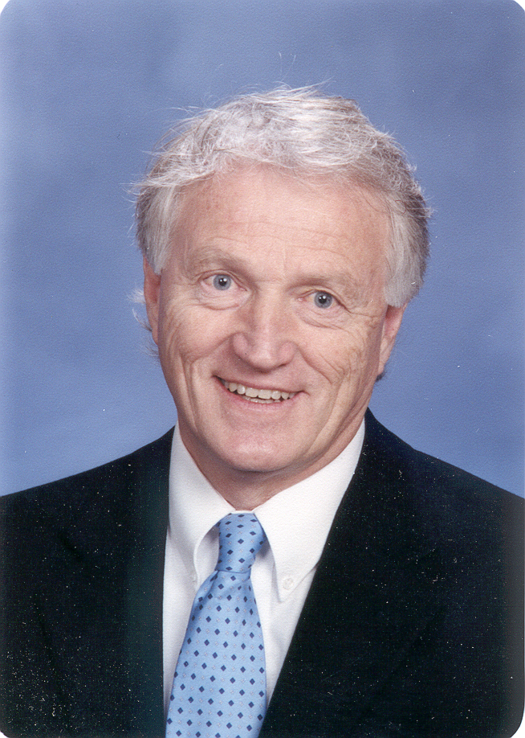 | KEYNOTE ADDRESS  Bruce Brown , Proactive Coaching, LLC  Topic: “The Impact of Trust”  Special Door Prizes & 50 / 50 Drawings  Presider: Ray Kosey, Superior, District I Representative  Bruce Brown  www.proactivecoaching.info  Nationally known presenter to over 600,000 people since 2002. 35-years experience as a teacher, coach, at Junior High, High School, Junior College and College level. Author of 11 books and producer of 12 instructional and character based coaching DVD’s and videos.
4:45 – 5:30 DISTRICT CAUCUSES
* Elections held -- in Districts 2, 4, 6 for District Representative and Gender Representative, and Middle School Representative.
District I Conference Center A District V Conference Center E
Presider: Ray Kosey, Superior Presider: Brian Smith, Waunakee

District II * Conference Center B District VI* Conference Center F
Presider: Stephanie Hauser, CAA, Stevens Presider: Signe Schecher, Mayville
Point Area Senior High
District III Conference Center C District VII Conference Center G
Presider: Bryan Yager, CAA, Reedsburg Area Presider: Corey Golla, Brookfield East
District IV* Conference D Retired Conference Center H
Presider: Kathy Bates, CMAA, Xavier Presider: Jim Scandin, Madison

SUNDAY, NOV. 7 – CONTINUED

6:00 – 7:30 Distinguished Service Awards Banquet Grand Ballroom
Please turn off cell phones.
Welcome: Linzi Gronning, CMAA, WADA President, Holmen
Invocation: John Frizzell, CMAA, Chippewa Falls
PRESENTATION OF DISTINGUISHED SERVICE AWARDS
District I Jerry Sullivan - Somerset
District II Todd & Michele Goska - Wisconsin Rapids
District III Richard Pampuch - Gale-Ettrick-Trempealeau
District IV WOMT/WQTC Radio - Manitowoc
District V Pete & Deb Hoffman – Iowa-Grant
District VI Jerry Moe - Clinton
District VII Jerry Cassidy – Menomonee Falls

7:30 – 10:00 PACKER PARTY Riverview Ballroom
Sponsored by WADA

7:30 – 10:00 EXHIBITS OPEN – WADA / Vendor Social Riverview Ballroom
Sponsored by MECA Sportswear
Host: Luke Francois, CMAA, WADA Vice President, Middleton
Exhibits / Vendor Coordinator: Brad Nemec, CAA, Somerset

Door Prize Drawings – throughout the evening
50 / 50 Raffle Drawings: Ray Kosey, Superior

7:15 p.m. ALL WADA MEMBERS: Photo Needed VIP Booth
Note: Any new AD and any other AD that has not had his/her picture taken by
VIP Photography in the past year needs to stop by the VIP booth and do so.

THANK YOU!!!
to all Our vendors for their support of THE WADA WORKSHOP!

MONDAY, NOVEMBER 8, 2010

As a courtesy to our presenters, please turn off cell phones during all presentations.
This includes mini-sessions, LTC classes, keynote addresses, etc.

7:30 – 8:30 WADA CONTINENTAL BREAKFAST Riverview Ballroom

7:30 – 12:30 EXHIBIT AREA OPEN Riverview Ballroom

7:30 – 10:15 Workshop Registration Grand Ballroom Lobby

7:30 – 10:15 ATTENDEE BENEFIT PICK-UP Grand Ballroom Lobby

8:00 – 8:45 WOMEN’S ATHLETIC DIRECTOR MEETING Conference Center A
Presider: Stephanie Hauser, CAA, District II, Stevens Point Area Senior High

8:30 – noon SPOUSE / GUEST ACTIVITY Condo 2102
“SMILE” presented by Judy Neve – following a light breakfast at 8:30 a.m.
Hosts: Sandy Nemec, Somerset

9:00 – 10:00 SECOND GENERAL SESSION Grand Ballroom
Please turn off cell phones.

Exhibitors Awards – Brad Nemec, CAA, Somerset
Presenter: Barry Alvarez, Athletic Director
University of Wisconsin-Madison

Presider: Greg Smith, CMAA, WADA Past President, West De Pere

Topic: “Building a Strong Team with Sound Leadership”
Barry Alvarez

10:15 Door Prize Posting IN VENDOR AREA Riverview Ballroom

 | YOUR ON-LINE CHANNEL FOR WIAA EVENTS
 | The Official Video Site of the WIAA

MONDAY, NOV. 8 – CONTINUED

10:30 – 11:15 FIRST SET OF MINI-SESSIONS – Please turn off cell phones.
1. “Captains – 7 Ways to Lead” Conference Center I
Presenter: Bruce Brown, Proactive Coaching LLC
Presider: Jim McClowry, CMAA, Sun Prairie

2. “Hosting WIAA Events—The In’s & Out’s” Conference Center H
Presenter: Mark Zahn, CAA, Seymour Presider: Greg Bell, Boscobel
3. “WIAA Amateur Status” Conference Center G
Presenters: Wade Labecki, WIAA Deputy Director
Tom Shafranski, WIAA Assistant Director
Presider: Dan Karius, RAA Slinger

4. “Building an Effective Strength, Conditioning and Post-Workout Refueling and Recovery Program” Conference Center F
Sponsored by the Wisconsin Milk Marketing Board
Presenter: Cal Dietz, M.Ed, Head Strength and Conditioning Coach, University of Wisconsin-Madison
Presider: Craig Lieder, CAA, Oshkosh North

5. “Developing Officials in Your Community” Conference Center E
Presenters: Bill Topp, Referee Magazine, Gary Williams, Carthage College, Abby Bickel, Referee Magazine, Jack Fleming, MCC Commissioner
Presider: Monte Phillips, CAA, Janesville Craig

6. “Dealing with the Challenging Parent” Conference Center C
Presenter: Greg Winkler, Fond du Lac
Presider: Mike Slagle, Plymouth

VENDOR DISPLAY/EXHIBITOR TIMES

RIVERVIEW BALLROOM

Vendors are to please keep booths open on Monday thru 12:30 p.m.
Sunday, Nov. 7–7:00 p.m. to 10:00 p.m.

Monday, Nov. 8–7:30 a.m. to 12:30 p.m.

MONDAY, NOV. 8 – CONTINUED

11:30 – 12:15 SECOND SET OF MINI-SESSIONS – Please turn off cell phones.
1. “The Power of Your Words” Conference Center I
Presenter: Bruce Brown, Proactive Coaching, LLC
Presider: Corey Baumgartner, CAA, Kaukauna

2. “Adaptive Scholastic Athletic Programming—ASAP” Conference Center H
Presenter: Damian Buchman, President ASAP
Presider: Bill Greymont, Beaver Dam

3. “Recruiting and Retaining Coaches” Conference Center G
Presenter: John Frizzell, CMAA, Chippewa Falls
Ray Kosey, Superior
Sandy Freres, CAA, The Prairie School
Presider: Len Collyard, CAA, Kettle Moraine Lutheran

4. “Building an Effective Strength, Conditioning, and Post-Workout Refueling and Recovery Program” Conference Center F
Sponsored by the Wisconsin Milk Marketing Board
Presenter: Cal Dietz, M.Ed, Head Strength and Conditioning Coach, University of Wisconsin-Madison
Presider: John Maltsch, Pewaukee
5. “Developing Officials in Your Community” Conference Center E
Presenters: Bill Topp, Referee Magazine
Gary Williams, Carthage College
Abby Bickel, Referee Magazine
Jack Fleming, MCC Commissioner
Presider: Peggy Seegers-Braun, CMAA, Divine Savior Holy Angels

6. “Crowd Safety: Who are you Letting in Your Events?” Conference Center C
Presenters: Jay Hammes, CAA, Racine Horlick
Doug Chickering, Retired WIAA Executive Director
Presider: Barb Chiszar, Hayward

12:30 Exhibit Area IS Closed

Continued on next page

MONDAY, NOV. 8 – CONTINUED

12:30 – 1:30 WADA AWARDS LUNCHEON, Sponsored by Healy Grand Ballroom

 | Please turn off cell phones.  Presider: Linzi Gronning, CMAA, WADA President,  Holmen  Invocation: Kathy Bates, CMAA, District IV  Door Prize Drawing   50 / 50 Raffle Drawing

WADA / NIAAA YEARS OF EXPERIENCE – 2010 AWARDS

10 YEAR
Barb Chiszar, Hayward
Connie Craig, Melrose-Mindoro
Stephanie DeVos, Hudson
Chris Heller, D.C. Everest Jr. High
Mike Hetzel, Wauwatosa West
Kathie Hugin, CAA, Milwaukee School of Languages
Brad Jodarski, CAA, Oshkosh West
Dan Karius, Slinger
Jim Kluge, Badger
Bob Lenz, Greenwood
Mike McHugh, DeForest
Dave Mueller, Manitowoc Roncalli
Dave Petroff, Menomonee Falls
Dan Retzki, Green Bay Preble
Rich Roginski, Eleva-Strum
Ron Schlitt, Hartford Union
Brian Skortz, Fond du Lac
Gene Spindler, Menasha
Mark Stein, RAA, Shoreland Lutheran
Bryan Yager, CAA, Reedsburg Area

15 YEAR WADA & NIAAA
Brian Bennett, Darlington
Linzi Gronning, CMAA, Holmen
John Maltsch, Pewaukee
Steve Salisbury, CMAA, Rice Lake
Cal Tackes, Stratford
Roger Toole, Bonduel

20 YEAR WADA & NIAAA
Gisela Benning, Milwaukee North
Gerry Blaha, Blair-Taylor
Mark Kopplin, CAA, New Lisbon
John Nolan, CAA, Milwaukee King
Bill Schweitzer, Amherst
Scott Tolzman, Dodgeville
Steve VanderWyst, Marshfield Middle School

25 YEAR WADA & NIAAA
Kevin Knudson, Barneveld
Jeff Sitz, CMAA, Wisconsin Lutheran

30 YEAR WADA & NIAAA
Jim Cliver, Ben Franklin Jr. High
Greg Gamalski, Catholic Memorial

35 YEAR WADA & NIAAA
Eugene Strusz, CAA, Fox Valley Lutheran
Don Tolkacz, CAA, Pulaski, Retired

SPECIAL AWARDS
Andy Anderson Award – Steve Salisbury, CMAA, Rice Lake
NIAAA DSA Award – Deb Hauser, WIAA Associate Director
Retired Athletic Director Award of Merit – Dave Johnson
NIAAA State Award of Merit – Bill Vickroy, CAA, Wisconsin Rapids Lincoln
NFHS Citation: Greg Smith, CMAA, West De Pere

District Athletic Directors of the Year AWARD

District I Brad Nemec, CAA, Somerset
District II Susan Kaltenberg Neumann, Shiocton (Presented Postumously)
District III Terry Allen, CAA, Regis
District IV Kathy Bates, CMAA, Xavier
District V Lois Peart, Iowa-Grant
District VI Leonard Collyard, CAA, Kettle Moraine Lutheran
District VII Jeff Sitz, CMAA, Wisconsin Lutheran

Continued on next page
MONDAY, NOV. 8 – CONTINUED

PRESENTATION, STATE ATHLETIC DIRECTOR OF THE YEAR AWARD

2:00 – 2:45 THIRD SET OF MINI-SESSIONS – Please turn off cell phones.

1. “LTI & Certification Process” Conference Center A
Presenter: Scott Lindgren, CMAA, Kenosha Schools
Presider: Greg Lampe, CAA, Oak Creek

2. Middle Level Caucus Conference Center B
*Election, WADA Board Middle Level Liaison
Presenter: Eric Check, WADA Middle School Representative
La Crosse Lincoln Middle School
Presider: Chad Steinmetz, CAA, Bloomer

3. “Athletic Director as a Servant Leader” Santa Fe 3010
Presenter: Cliff Thompson, CAA, Sauk Prairie
Presider: John Cleaver, CAA, Oshkosh Lourdes

4. “Evaluating Coaches & Athletic Programs” Laguna
Presenter: Jim McClowry, CMAA, Sun Prairie
Presider: Dave Petroff, Menomonee Falls

5. “WADA Coaches Handbook” I
Presenters: Sig Schecher, Mayville; Vickie Dahl, CAA, Mineral Point; Brian Smith, Waunakee
Presider: Mike Rupnow, Racine Case

3:00 – 3:45 ROUNDTABLE DISCUSSIONS – Please turn off cell phones.
Attendees will be assigned alphabetically, by school name, to each group
Topics:
1. WIAA Minimum Code Requirements
2. WIAA Transfer Rule—Modifications to Address Current Issues

Group 1 --- Abbotsford to DeForest Conference Center I
Presenters: Pam Huston, D.C. Everest
Corey Golla, Brookfield East

Group 2 --- Delavan-Darien to Laconia Conference Center H
Presenters: Ray Kosey, Superior
Stephanie Hauser, CAA, Stevens Point Area Senior High

Group 3 --- Ladysmith to North Crawford Conference Center G
Presenters: Greg Smith, CMAA, West De Pere
Kathy Bates, CMAA, Xavier

MONDAY, NOV. 8 – CONTINUED

Group 4 --- North Fond du Lac to Shoreland Lutheran Conference Center F
Presenters: Linzi Gronning, CMAA, Holmen
Brian Smith, Waunakee

Group 5 --- Shorewood to Youth Initiative Conference Center E
Presenters: Luke Francois, CMAA, Middleton
Bryan Yager, CAA, Reedsburg Area
4:00 – 8:00 NIAAA LEADERSHIP TRAINING INSTITUTE COURSES Please turn off cell phones. * Pre Registration and Advance Fee Required

LTC – 501 Conference Center A
Athletic Administration: Philosophy, Leadership, Organizations and Professional Development
Facilitators: Sandy Freres, CAA, The Prairie School and Jim Sekel, CAA, Cadott

LTC – 504 Conference Center B
Athletic Administration: Legal Issues and Strategies in Athletics
Facilitators: Greg Smith, CMAA, West DePere and Jim McClowry, CMAA, Sun Prairie

LTC – 612 Conference Center C
Athletic Administration: Technology I – Basic Computer Application
Facilitator: Jack Klebesadel, CAA, Germantown

LTC – 630 Santa Fe 3016
Athletic Administration: Interscholastic Contest Management – Planning, Preparation and Methods
Facilitators: Jay Hammes, CAA, Racine Horlick and Mike Novak, CAA, Brown Deer

LTC – 714 Santa Fe 3020
Athletic Administration: Dealing with Challenging Personalities
Facilitator: John Frizzell, CMAA, Chippewa Falls

LTC – 719 Laguna
Athletic Administration: Leadership, Management/Supervision and Decision Making Concepts, Methods and Applications
Facilitators: Becky Dziekan, CAA, Zion High School, IL and Dave Kapp, CAA, Madison East

7:30 – ??? NFL Monday Night Football Party Grand Ballroom
Sponsored by Jay Hammes, Safe Sports Zone and Badger Sporting Goods
Hosted by the WADA Executive Board

7:30 – ??? Spouse & Guest Game Night North Tower - Room 3001
Hosts: Dave and Jane Gunderson, Retired; Jack and Joan Cepek, Retired
Sandy Nemec, Somerset
TUESDAY, NOVEMBER 9, 2010
As a courtesy to our presenters, please turn off cell phones during all presentations.
This includes mini-sessions, LTC classes, keynote addresses, etc.

7:00 a.m. Fellowship of Christian Athletes Breakfast Conference Center G-H-I
 | Invocation: Mark Hull, FCA  Presenter: Bill Butters, University of Wisconsin-Madison  Presider: Jack Overgaard, CAA, Retired

8:30 – 9:30 THIRD GENERAL SESSION Grand Ballroom
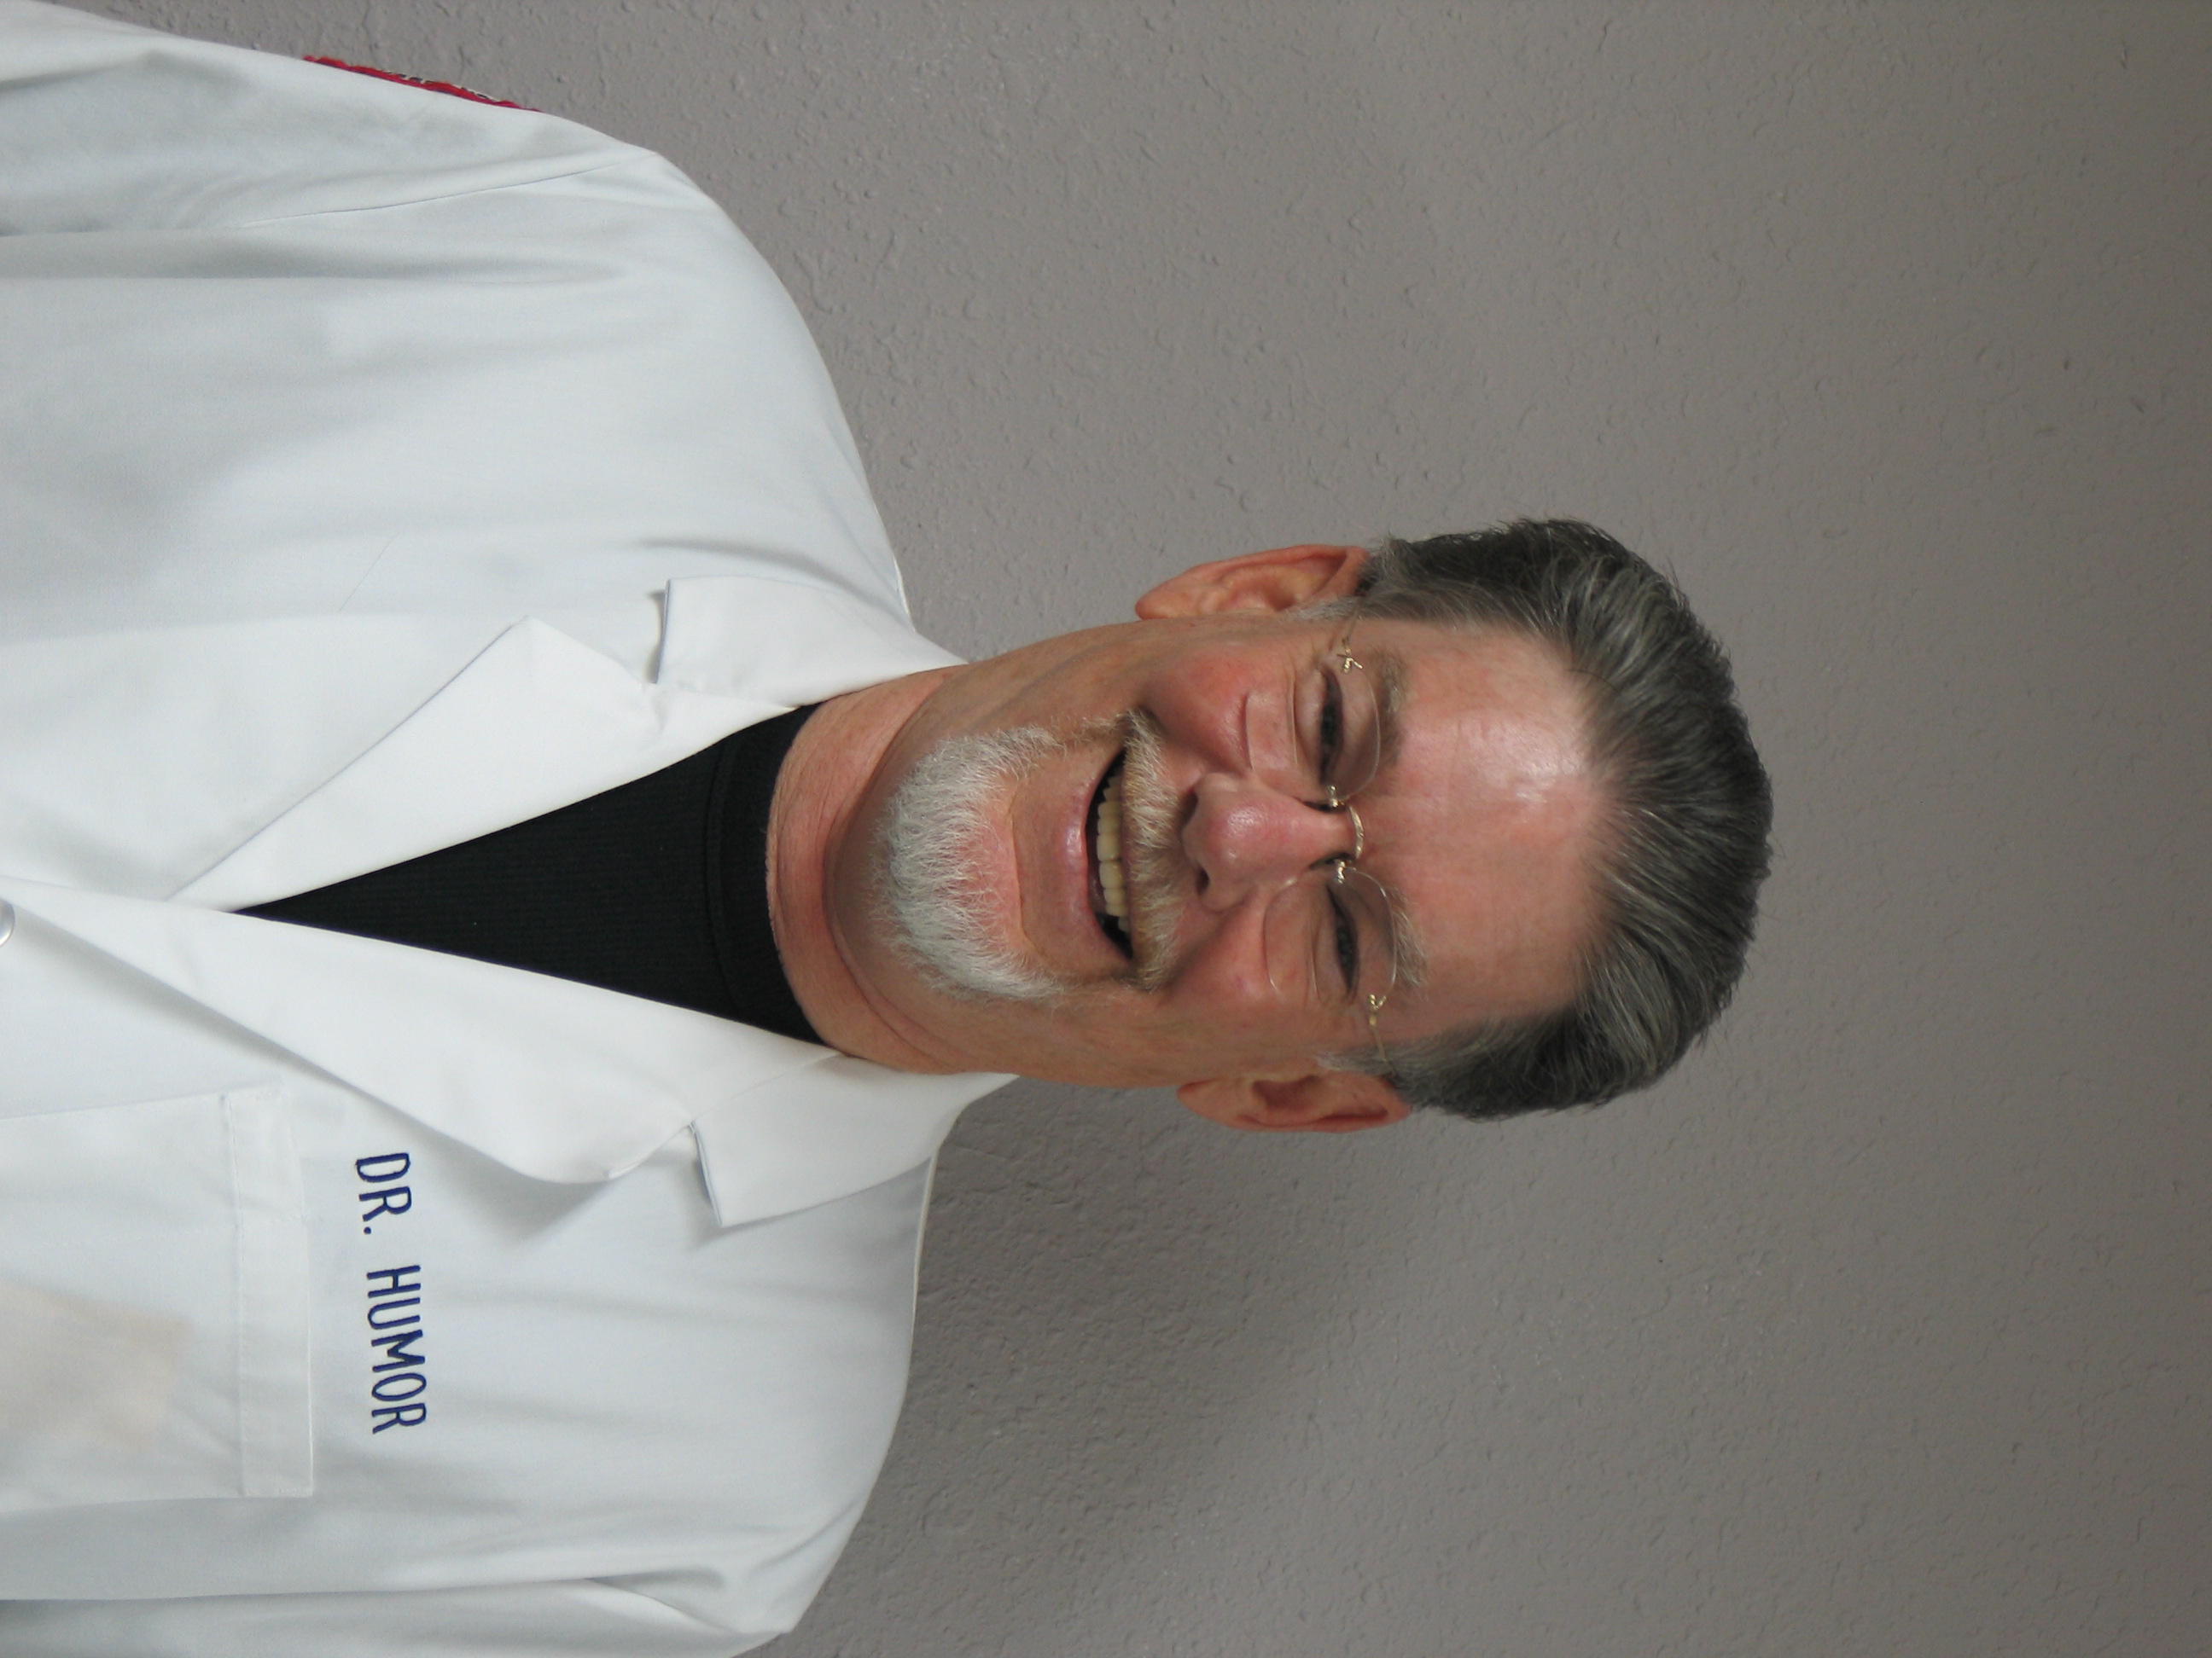 | Please turn off cell phones.  Presider: Linzi Gronning, CMAA, WADA President, Holmen  Presenter: Dr. Stuart Robertshaw “Dr. Humor”  Topic: “The Healing Power of Humor”  Dr. Stuart Robertshaw, Professor Emeritus of Psychology and Education at the University of Wisconsin-La Crosse and an Attorney, researched and presents on the benefits of humor. He formed the National Association for the Humor Impaired, receiving national attention in over 144 newspapers, 180 radio stations and has been featured in magazines such as Family Circle and Mature Outlook. Dr. Robertshaw, whom the press refers to as "Dr. Humor," will share what he has learned about the psychological and physiological benefits of humor and laughter.
9:00 – 11:00 Hospitality Room Open for Spouses and Guests North Tower - Room 3001

 |  | Chula Vista Resort and Conference Center  The WADA Board is pleased to provide this site in  Wisconsin Dells for the annual WADA Workshop…  Mark your calendar now for future years.
 |  | ChulaVistaResort.com
TUESDAY, NOV. 9 – CONTINUED

9:35 – 10:15 WADA ANNUAL MEETING Grand Ballroom
Please turn off cell phones.

Presider: Linzi Gronning, CMAA, WADA President, Holmen
Recorder: Mike Bates, WADA Information Director
Approve Minutes from WADA 2009 Annual Meeting

Election of WADA Vice President
Presider: Stephanie Hauser, CAA, District II Representative,
Stevens Point Area Senior High

Report of Financial Audit / Budget
Presider: Joe Beran, CAA, WADA Treasurer, La Crosse Central

Approval of Changes to the WADA Bylaws
Presider: Bryan Yager, CAA, Reedsburg Area, District III Representative

WADA Scholarship Awards
Presider: Stephanie Hauser, CAA, WADA District II Representative
WADA Scholarship Committee Chair, Stevens Point Area High School

Strategic Planning, WADA
Presider: Pam Huston, WADA President Elect, D.C. Everest

TV Giveaway – Ray Kosey, District I Representative, Superior

10:15 – 11:45 WIAA FORUM Grand Ballroom
Presenters: Wade Labecki, WIAA Deputy Director
Presider: Sig Schecher, WADA District VI Representative, Mayville

11:45 - 12 Meeting for WADA Members attending NFHS / NIAAA National Conference
Dec. 15-19, 2010 in Orlando, Florida Grand Ballroom Lobby
Presider: Pam Huston, WADA President Elect, D.C. Everest

12:30 WIND-UP LUNCHEON Conference Center G-H-I
Presider: Linzi Gronning, CMAA, WADA President, Holmen
Invocation:

Election Results:
► WADA Vice President
► New WADA District Reps & Gender Reps in
Districts 2, 4, 6, and Middle School Representative

Delegates to the NFHS / NIAAA National Conference
Dec. 15-19, 2010 in Orlando, Florida

Passing of the Presidency – Linzi Gronning, CMAA, Holmen
TUESDAY, NOV. 9 – CONTINUED

Presentation of Past President’s Plaque – Pam Huston, CAA, D.C. Everest

President’s Ring and Door Prize Watches sponsored by ESCO

District Prizes, Door Prizes & Final 50 / 50 Drawings
Presider: Ray Kosey, District I Representative, Superior

1:30 WADA EXECUTIVE BOARD MEETING Executive Board Room
WADA President Pam Huston, D.C. Everest
Introduction of new WADA Board Members & 2010 WADA Workshop Review

2:00 WADA OFFICERS MEET WITH STAFF FROM
CHULA VISTA RESORT Executive Board Room

27th annual
WADA GOLF OUTING
Wednesday, July 13, 2011
The Ridges Golf Course, Wisconsin Rapids

Mark your calendar with the date… and join us for some fun!
Registration form will be available on the WADA web site:
www.wadawi.org

__ INSERT the PDF files

__ 20 TOTAL PAGES 5 SHEETS

